Q1:   
Spark and Smartphone/Watch Application

**Implement a smart application with big data analytics related to your project**

**Showing the collaboration between Spark and Smart Apps. Implement Twitter Streaming and perform word count on it and publish the results and showcase it in your SmartPhone/Watch Application**

Collected the popular hash tags with several award categories for every minute and took the count of the tags. Sent these twitter streaming data to the android phone using socket connection.

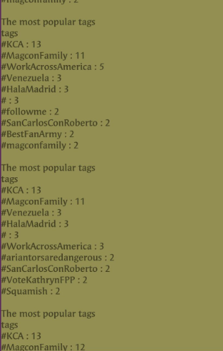

Q2: Spark ML Lib Application

Perform a machine learning algorithm with the Twitter Streaming data to categorize each Tweet.

1)Training datasets: Collect different categories of Tweets related to your project.(Categories can be based on Hash Tags /Subjects etc.)

2)Test data: the upcoming twitter stream